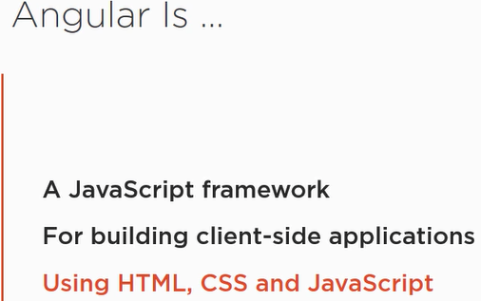

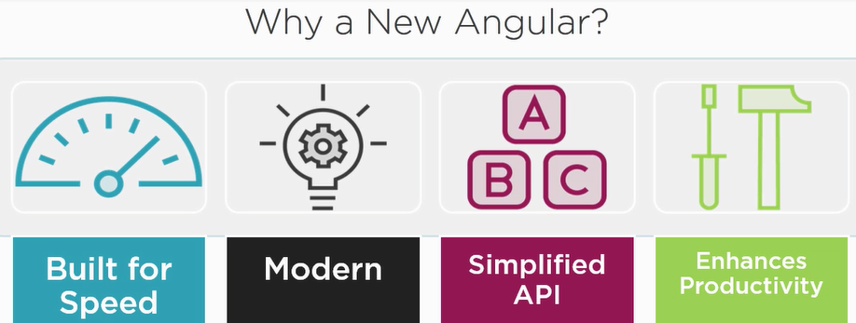

Component:

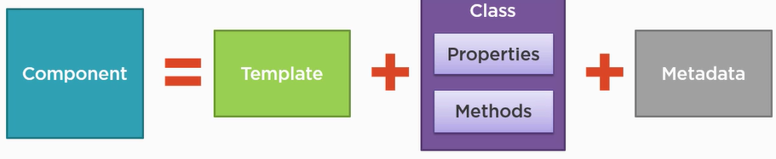

The next step is to install [Angular-CLI](https://cli.angular.io/). This tool is what helps you create Angular projects and makes other development tasks easier.

**\*note**: ng serve command launches the server, watches your files, and rebuilds the app as you make changes to those files*

When we build these component how do we pull them together?

Angular modules help us organize our application into piece of block of functionality. Every angular application has at least one angular module, called applications root modules. Application can have additional modules.

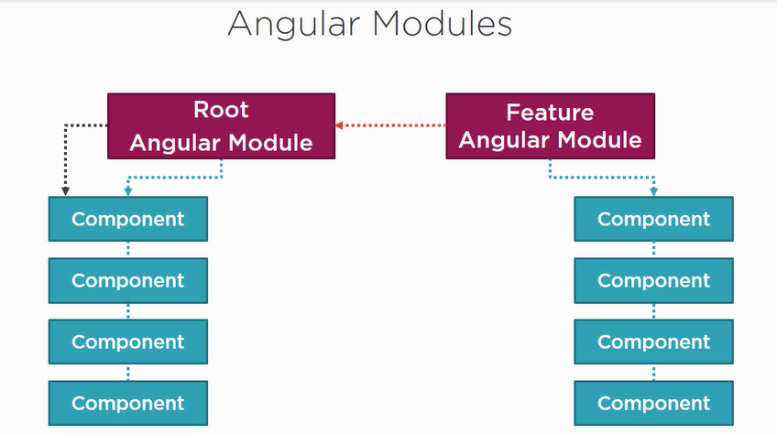

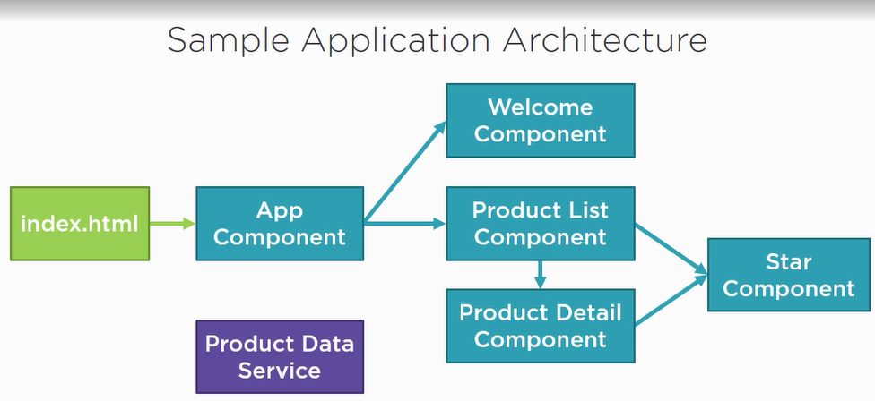

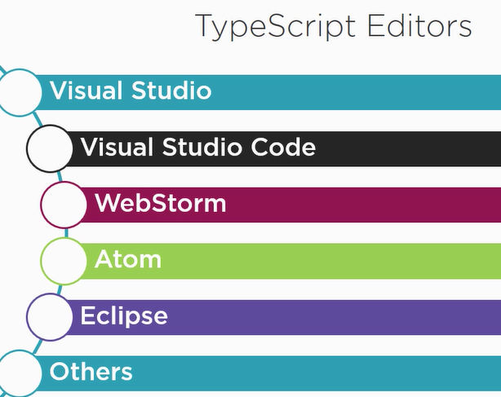

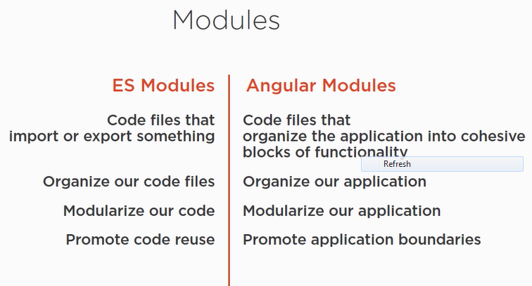

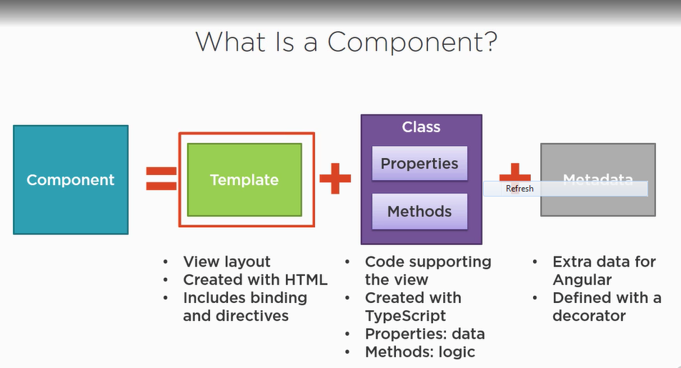

Decorate is a function that adds metadata to a class.

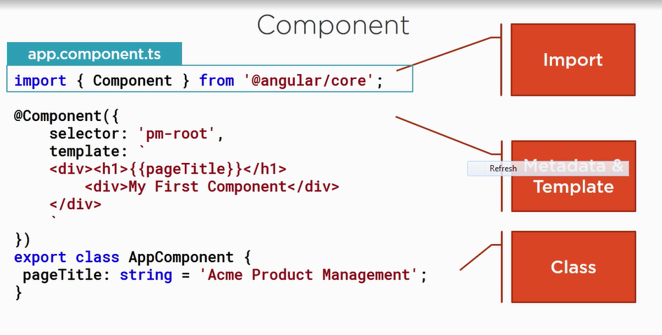

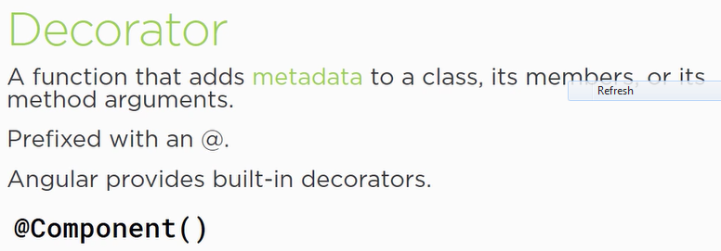

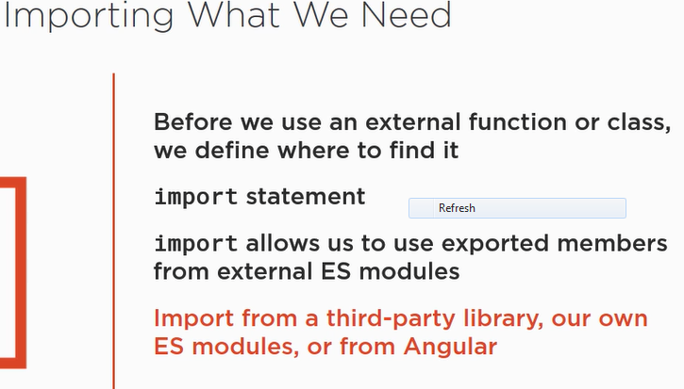

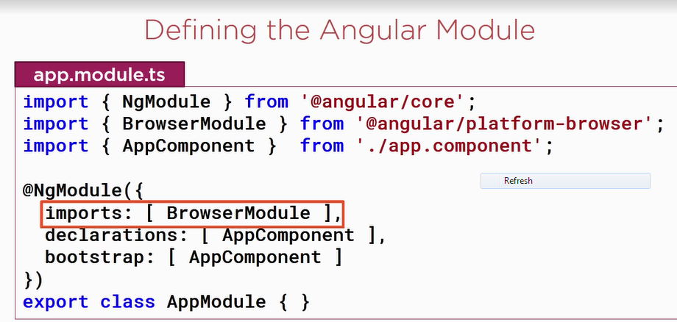

@NgModule decorator contains array properties.

index.html already hosting our application and app.module already boostatrcomponent.

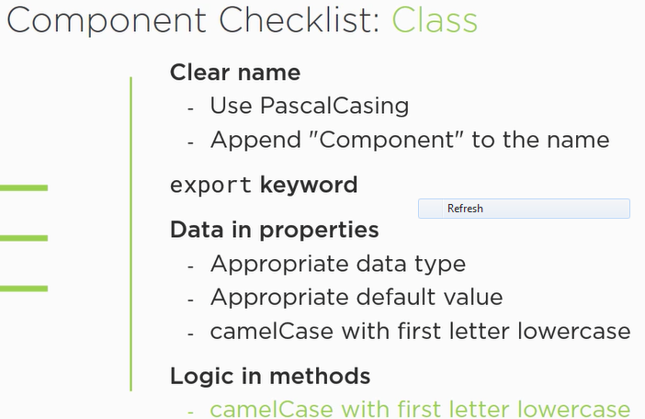

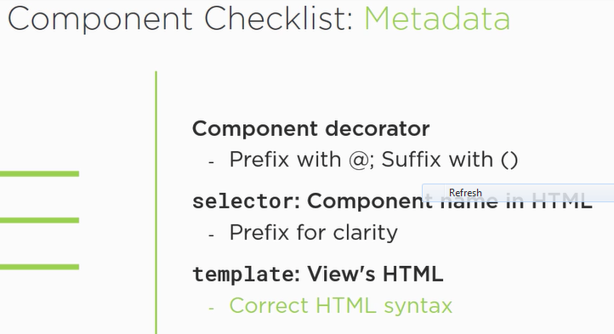

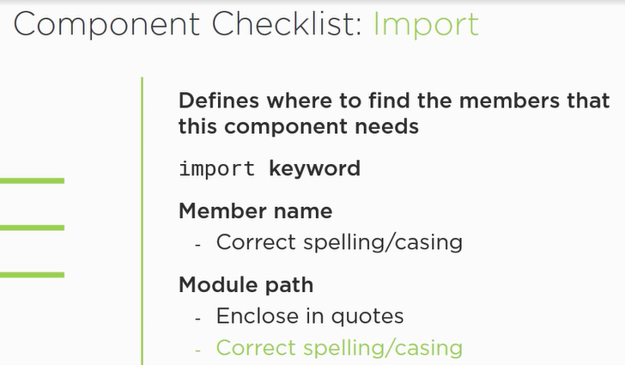

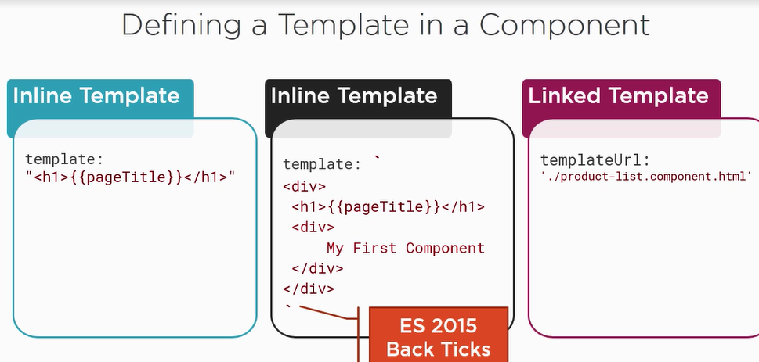

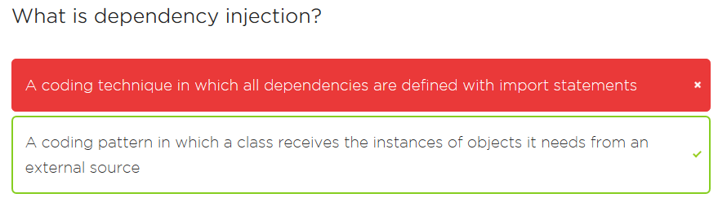

1. Component decorator makes a class component.
2. We can use selector as a directive.
3. We need to add our component to Angular App Module.

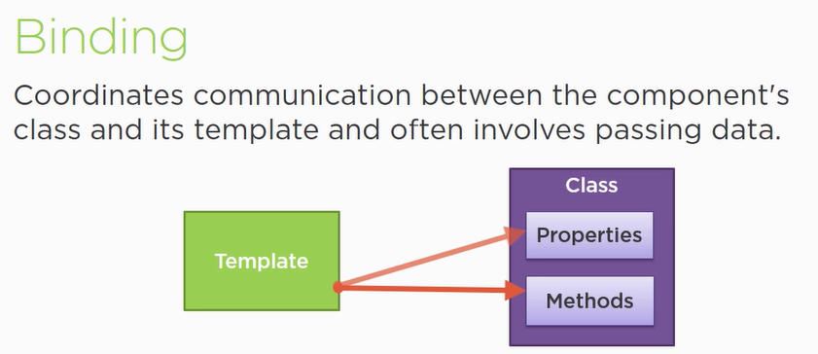

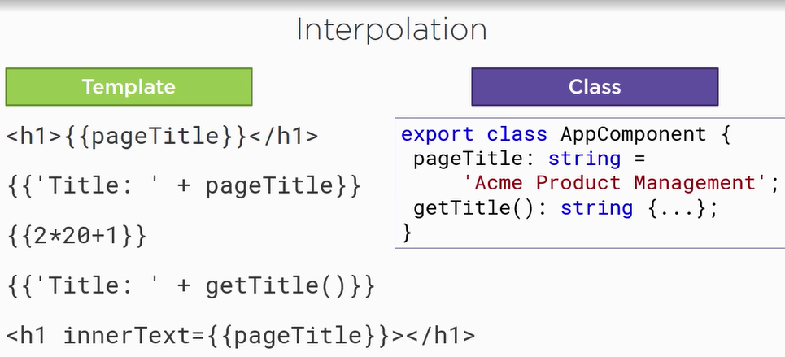

Interpolation is a one way binding, where data is transferred from class to template. We use for read only scenarios, we can also perform addition using interpolation.

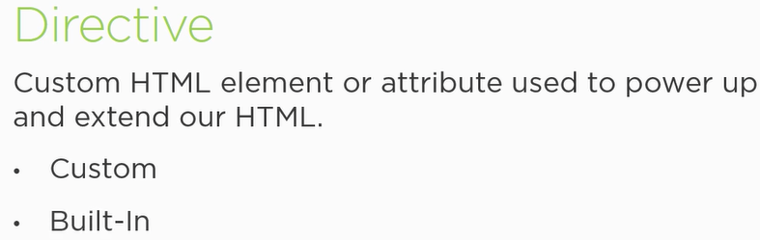

*NgIf

*NgFor

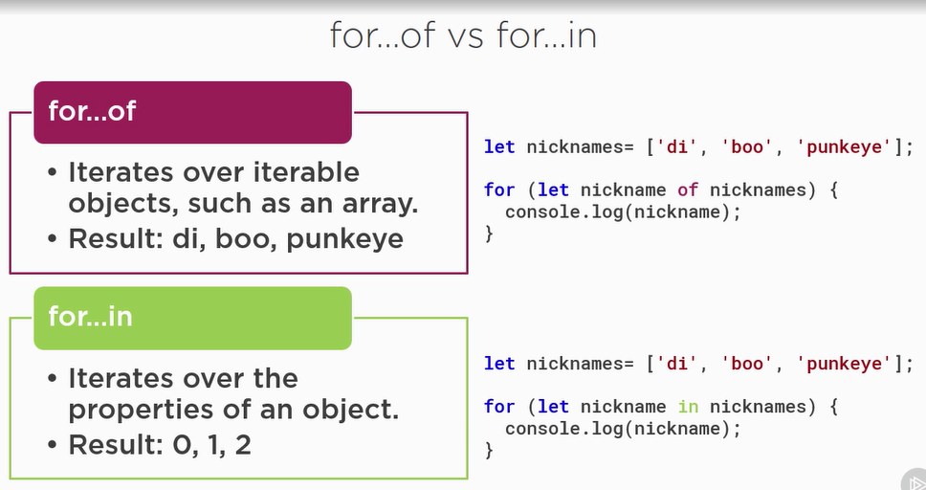

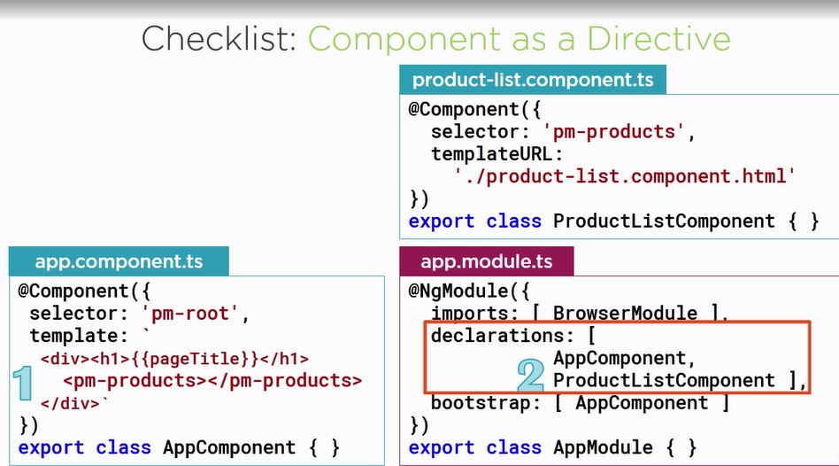

Binding:

Interpolation, property binding, two way bindings.

Sometimes data don’t come in handy that’s why we use pipe.

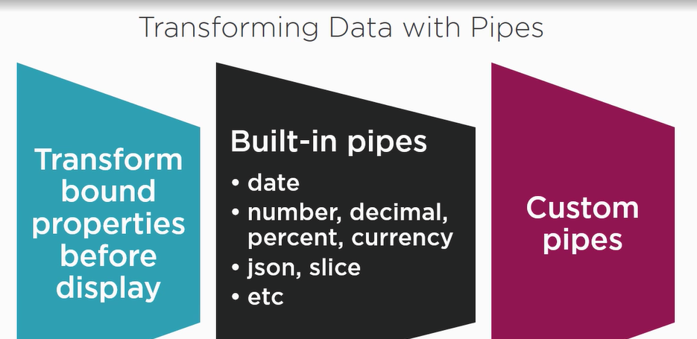

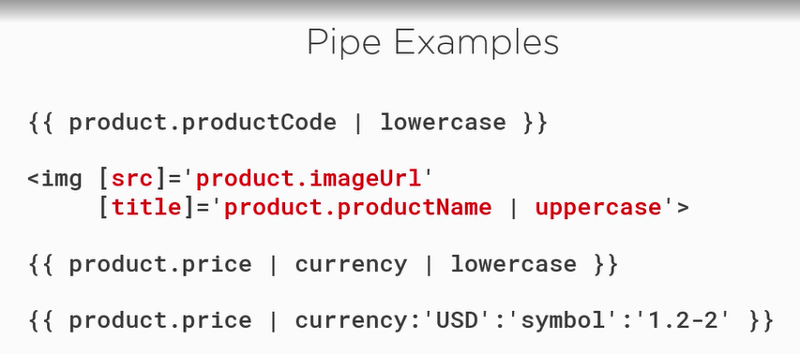

We can simply do data transformation using pipes for more user friendly data.

1. For NgModule we need to import FormsModule in the component.

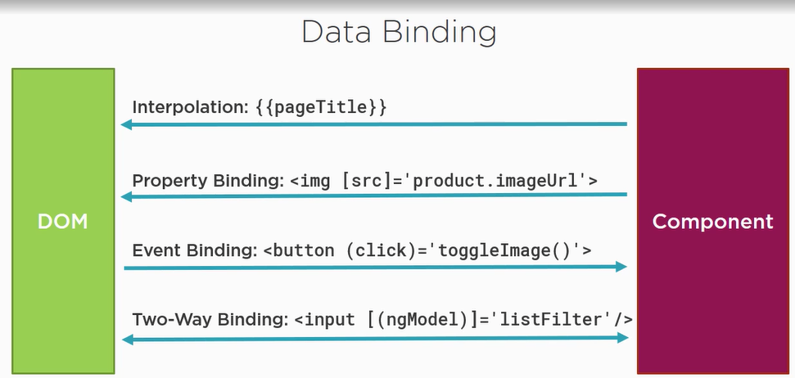

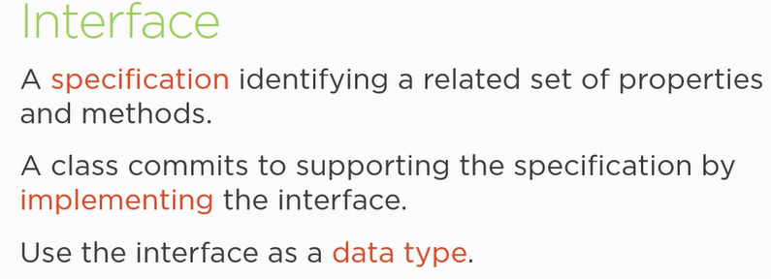

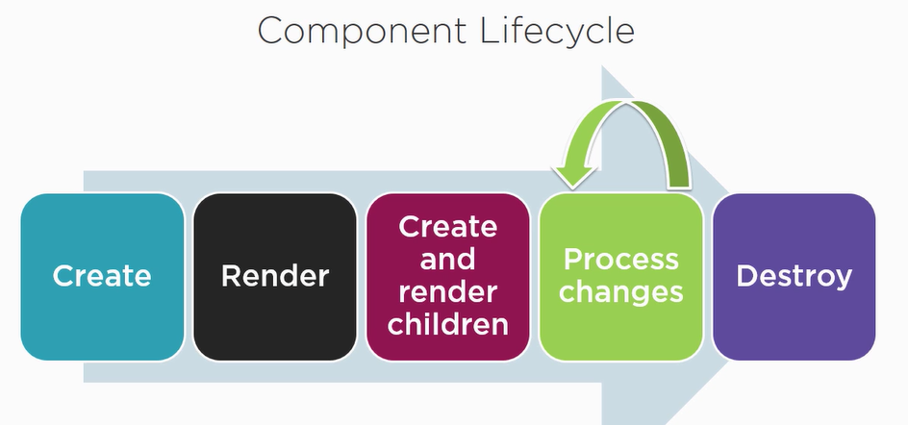

A component has lifecycle managed by Angular. Angular creates it, render it, creates and render its children process changes when its data bound properties change and destroy it.

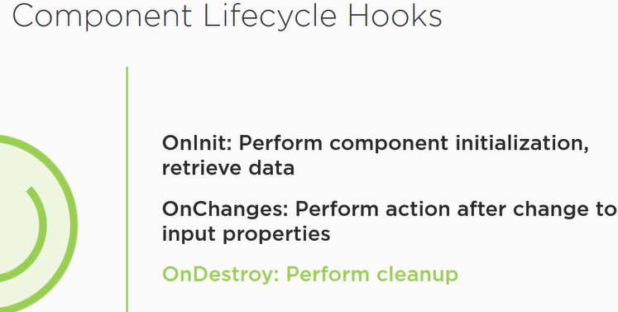

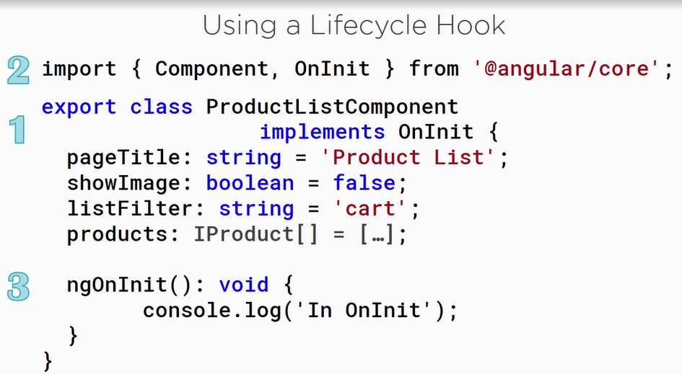

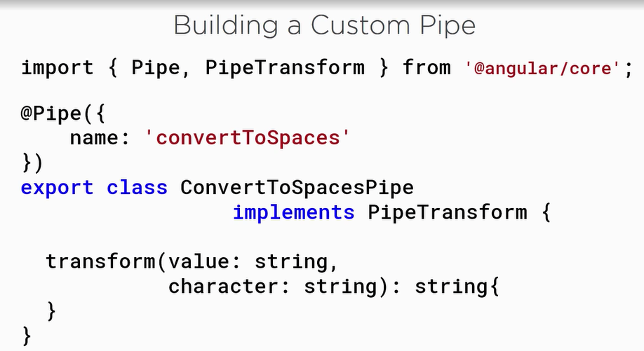

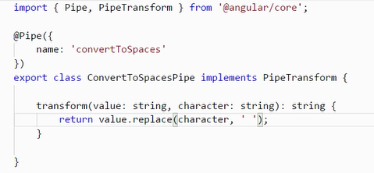



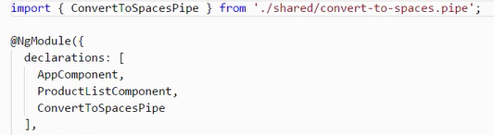

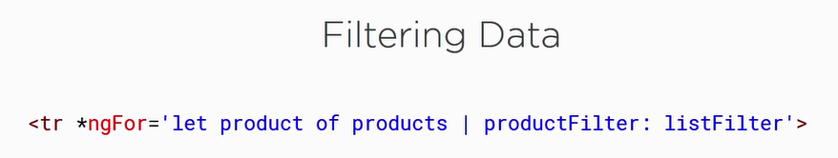



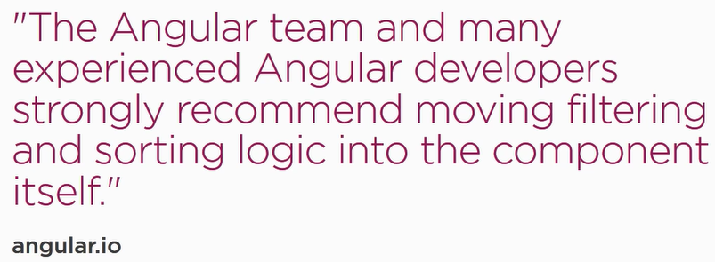

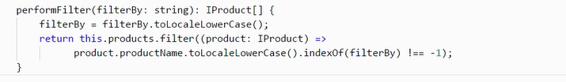

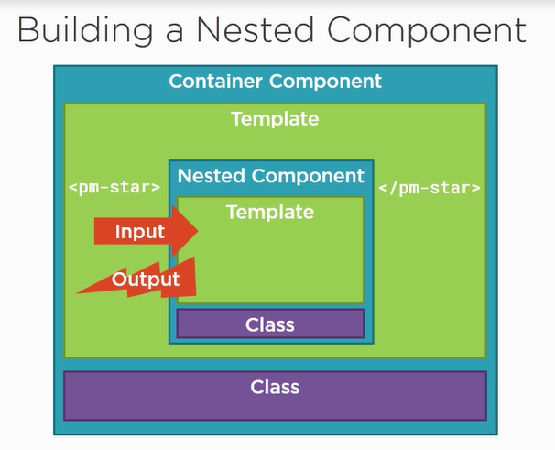

If a nested conatiner wants to use value from main container then nested container can use @Input()

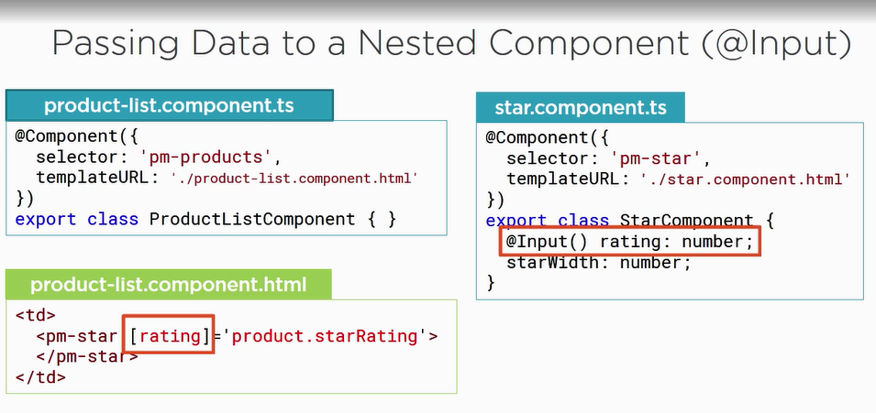

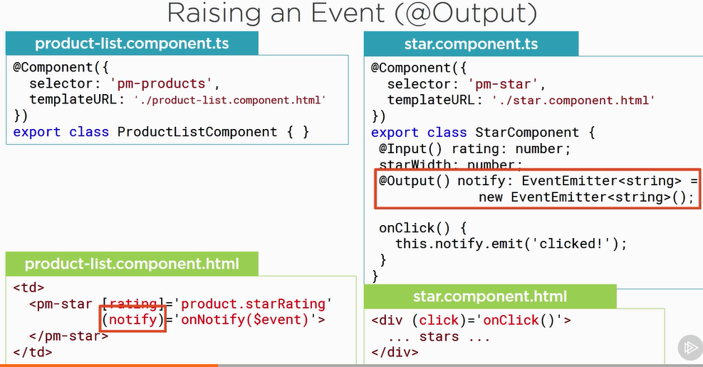

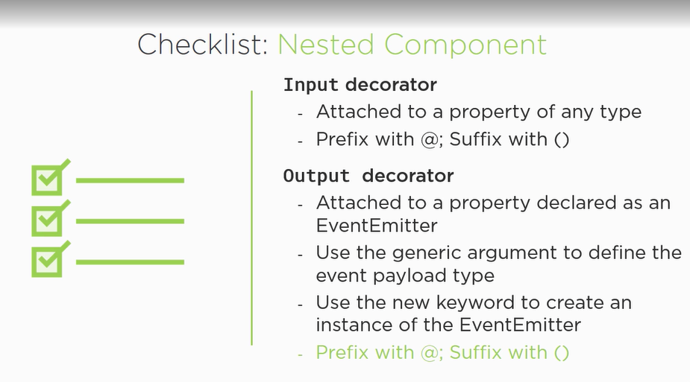

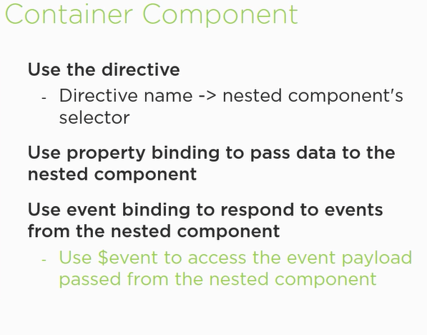

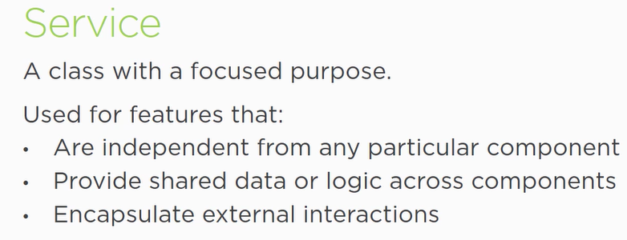

1. the component can create instance of the service class and use it.

but the instance is local to the component, so we cant share data with other resources.

2. we can register the service with angular , Angular then creates single instatnce of the class - singleton

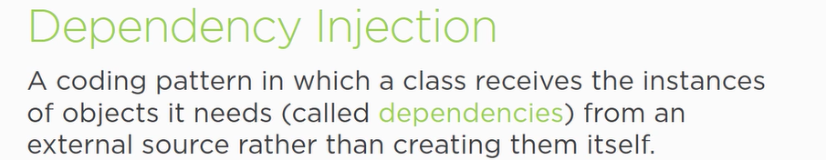

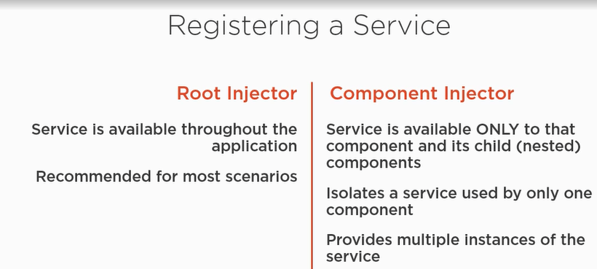

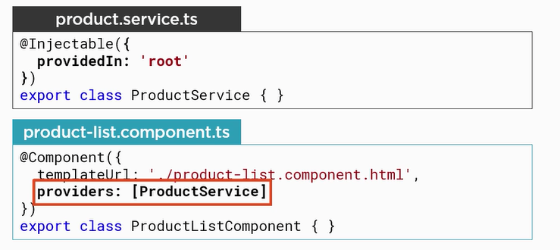

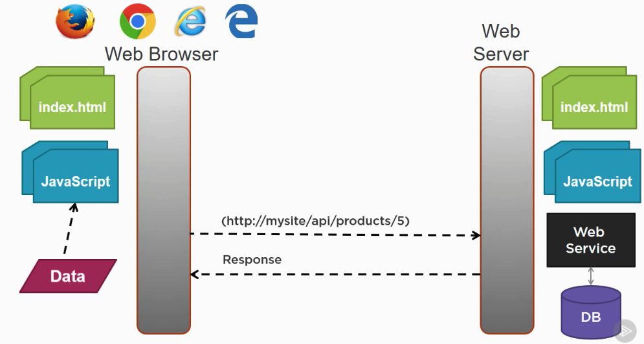

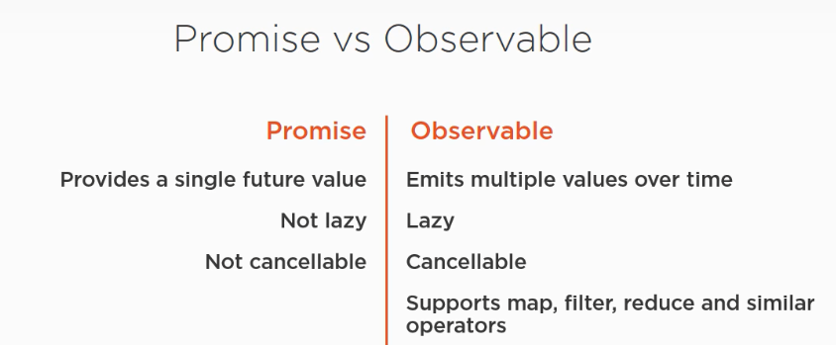

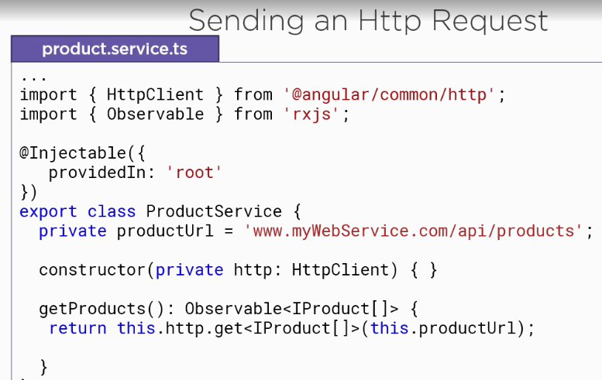

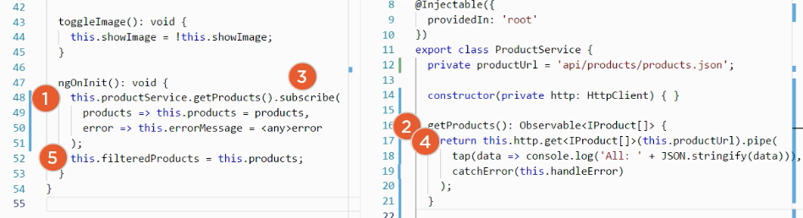

1. Angular first initializes the component and execut NgOnit method, we call the product methods of the product service.
2. The product service returns the observable of IProduts array, we subscribe to that method and HTTP request get submitted.

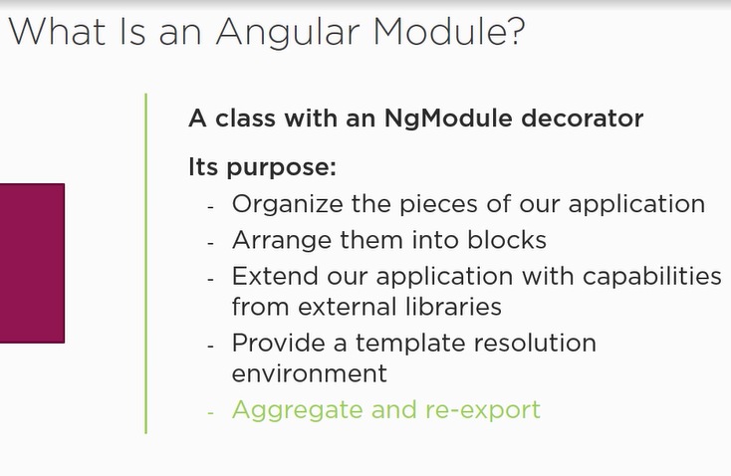

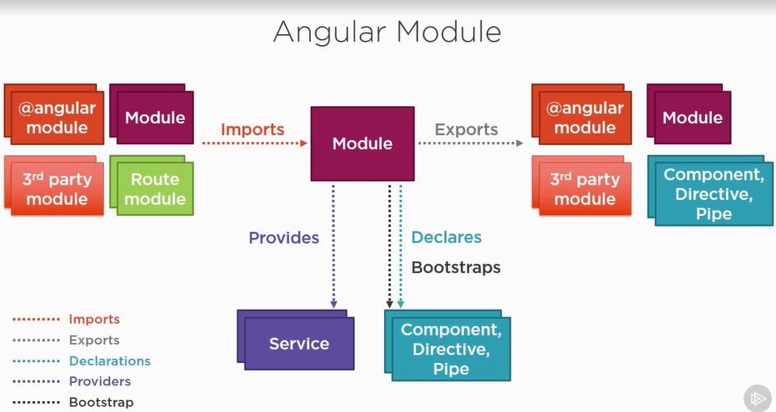

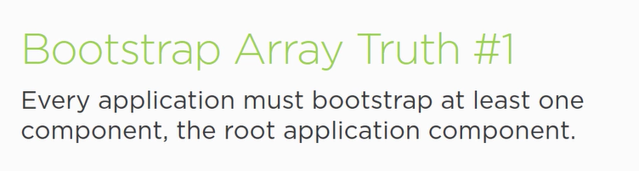



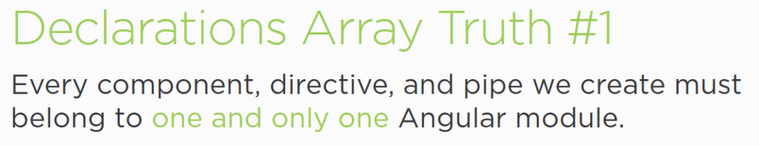



Don’t declare classes. Don’t redeclare component, directives or pipes.

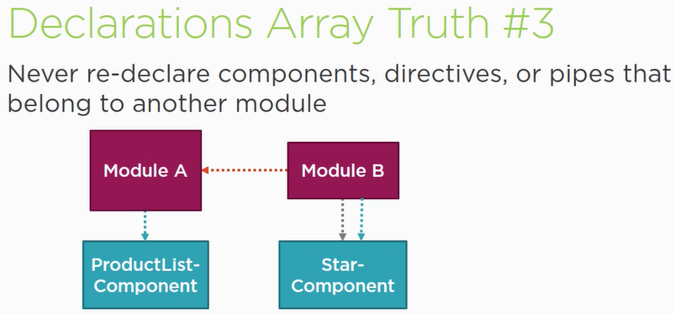

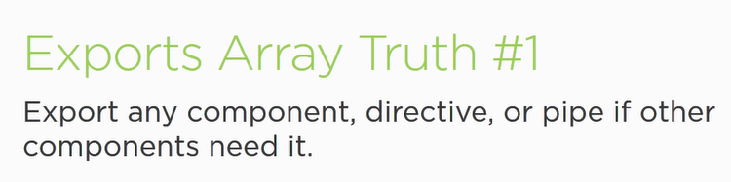

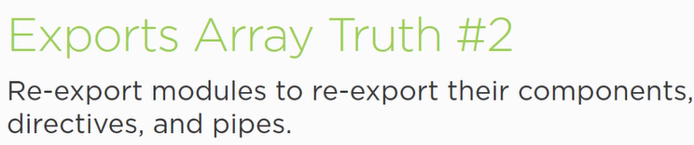

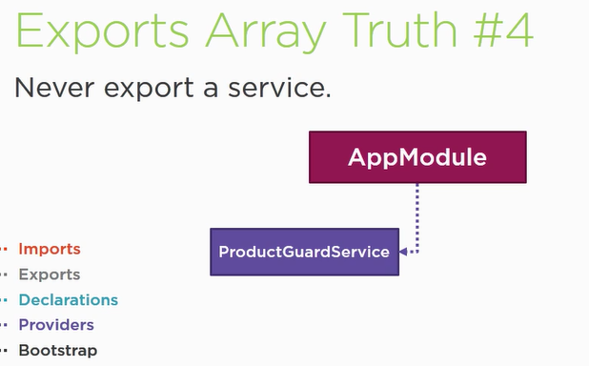

Service class is added to the root app, so its shared to all component. We don’t need to export it.

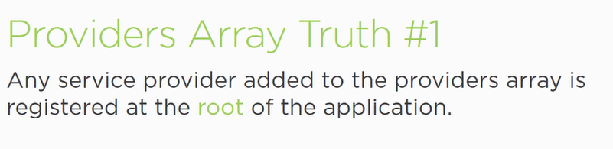

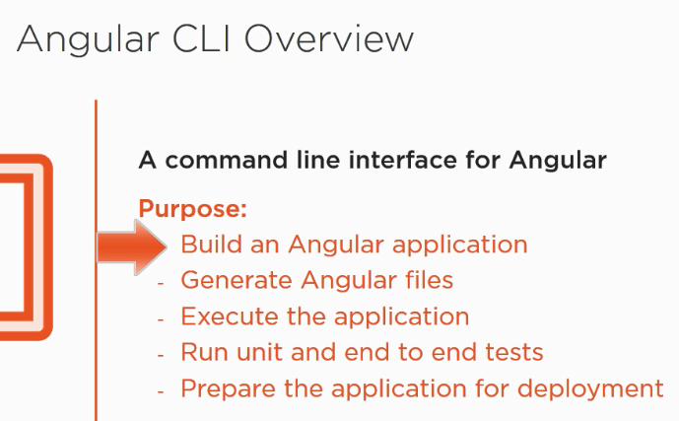

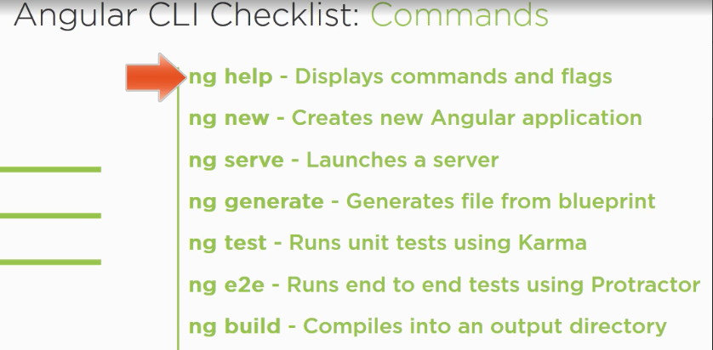

1. Npm start – it will run typescript complier(it will start lite-server) which wil host our apoplication.
2. Tsc: w – typescript compiler in watch mode that will compile automatically.
3. Flow of Angular:
4. Starts with index.html

<script> system.import(‘app’)</script>

1. System.config.js
2. Goes to main.js but will read main.ts

Angular 4:

1. e2e = requires for testing end to end
2. src = we create our application
3. index.html = this is the single page on which we work
4. assets = stores static files
5. Decorator: @component({})
6. In angular there is one main component : root component and other component
7. Backtick allow multiple html lines

Main Features / structures of Angular

Components

Data Binding

Directives

Routing

Observables

Forms

Pipes

Http

Animation and testing

Services

Typescript

TypeScript is a typed superset of JavaScript that compiles to plain JavaScript. TypeScript is pure object oriented with classes, interfaces and statically typed like C#

Typescript doesn’t run in browser and it compiled to javascript that’s why we need CLI.

App Model : It is a bundle of component

Data Binding : communication

Directive: Directives are instructions in the DOM(HTML).

Componenets are kind of directives

Ng if , ng for